Functional response protocol.
Background
Functional responses are used to quantify the potential strengths of trophic interactions between predators and prey. They describe relationships between prey density and the number of prey consumed by predators, and can be described as “Mechanistic analyses” as the relationships are based on two biologically realistic parameters, the predator’s attack rate (a) and handling time (h).
This protocol is intended for use on larger aquatic bromeliad predators (such as odonates and dytiscids) feeding on other macro-inverts (larvae of mosquitoes, chironomids, tipulids, scirtids etc). The protocol is intended to let researchers distinguish between type I, II, and III functional responses.
Central to the calculation of functional response curves is identifying the shape of the relationship at low prey densities (the “origin”), and finding where the curve levels off. The shape of the curve at the origin describes whether the predator has a type II or type III response when feeding on this type of prey. The leveling-off point describes the maximum number of prey a predator can consume within the time frame of the experiment, and is crucial to accurately calculating handing time. These regions are highlighted in the figure below.
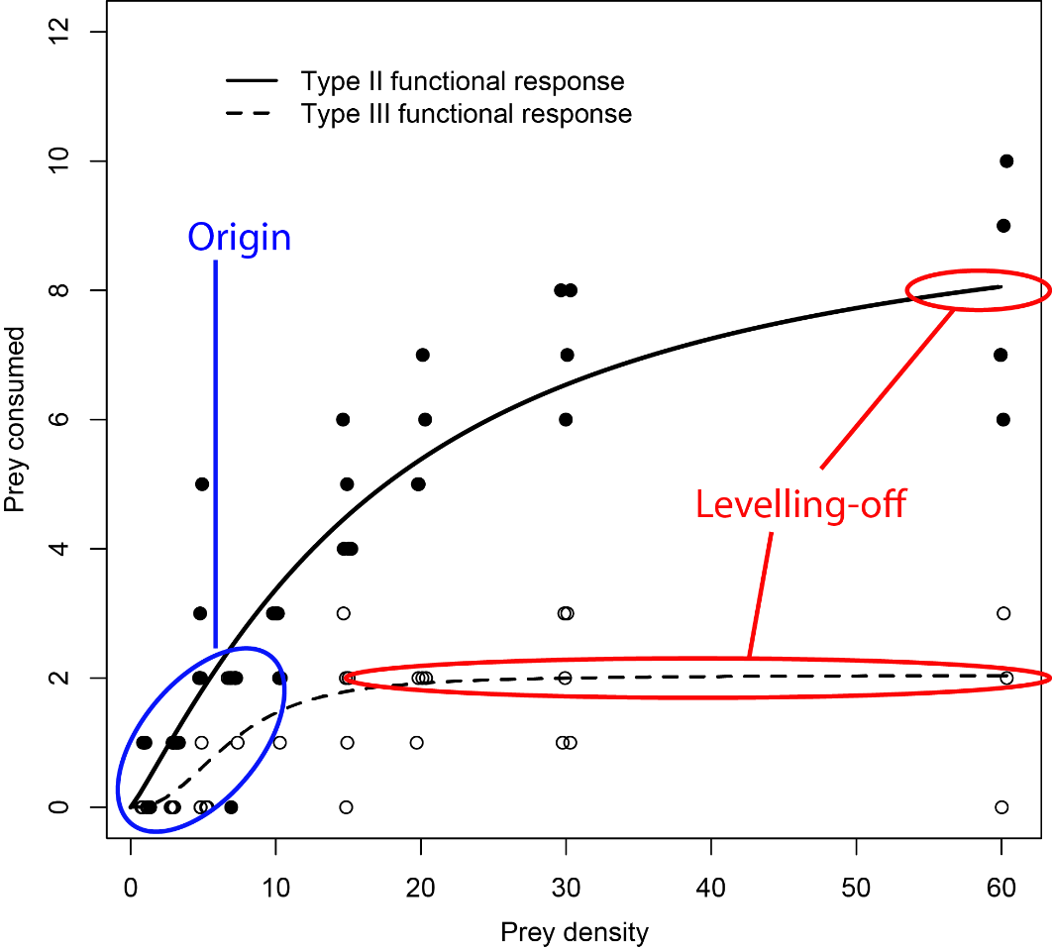
Figure 1 – Type II and III functional responses and important regions of the curve. A Type III functional response differs from a type II by having an inflection at the origin. Note that in this example, another higher prey density treatment would have been useful to ensure the type II fully levelled off. Taken from Hammill, Petchey and Anholt 2010. Predator functional response changed by induced defenses in prey. American Naturalist.
Conducting bromeliad functional response experiments
Vessels – 500ml Black plastic cups containing 200ml of media under ambient lighting. Black plastic prevents light coming in from the side, which seemed to upset some predators.
Predators – Try to ensure predators are of a similar size as body size can substantially affect consumption rates. If using odonates, ensure all individuals are of the same instar unless this is part of the experimental treatment
Prey – prey should also be size matched and of the same instar (unless this is an experimental treatment). For example, all the prey we used in the freshwater biology paper (Edd Hammill^{1,2}, Trisha B. Atwood^{3,4} , Paloma Corvalan^{1,5} and Diane S. Srivastava¹ - Behavioural responses to predation may explain shifts in community structure) were 4th instar mosquitoes.
Experimental prey densities and replicates – Ensure you have adequate replication and treatments at low prey densities to estimate the curve shape at the origin (these are easy as few prey are required) and enough at high densities to find the levelling-off point. I would recommend a minimum replicates of 1,2,3,4,5,7,10,15,20,30 prey individuals for mosquitoes, if each feeding trial lasts for 1hour. If you wish to double check whether 30 individuals will be sufficient to reach the levelling-off point, try feeding a predator manually with a pipette one prey item after another (this works for odonates). Time how long in minutes a predator takes to eat 10 individuals. Divide 60 by the number of minutes taken to eat 10 individuals, then multiple this number by 10 to get an estimate of the highest number of prey to offer in the expt.
Protocol for running the expt – Place prey in the experimental vessels and allow to settle (5 minutes). Add a single predator to the experimental vessels after the prey-settling period, and leave to incubate for 1 hour. After this time quickly remove the predator and count any remaining live prey. DO NOT COUNT dead prey, they may have been killed by the predator.
For larger prey (such as tipulids or scirtes, you may need to leave the predator for 2 hours.

Analysing functional response data
The R –code provided with this protocol contains the necessary details.

