Biology 413 (Zoogeography) Practice Mid-term Exam
Winter Term 2 - 2020
Directions:
- Write your name and student number on each page of the exam.
- Use the space provided for your answers. You can use the back of the final page for extra space, but label your answers clearly. If you need additional sheets of paper, let me know.
- You will have 50 minutes to complete the exam. Plan accordingly.
- The exam questions are organized into two parts and consist of 5 pages.
- PART I consists of 6 short-answer and multiple part questions.
- PART II consists of 3 long-answer (essay-form) questions.
Marks
PART I: 22 points
PART II: 28 points
TOTAL: 50 points

PART I
Answer the following questions 1 – 6, using 1-2 sentences or less (point-form is OK) in the space provided. These questions should take no more than 3-5 minutes each.

Question 1 [3 points]:
El Niño Southern Oscillation (ENSO) is an irregular period of weather change that occurs every 2-7 years due to strengthening of the equatorial countercurrent over the tropical eastern Pacific Ocean.
How does ENSO positively or negatively affect land and marine animal communities in these regions?

Question 2 [4 points]: Comparing a to a’ and b to b’ (Figure 2), explain the differential heating of Earth’s surface at low versus high latitudes:
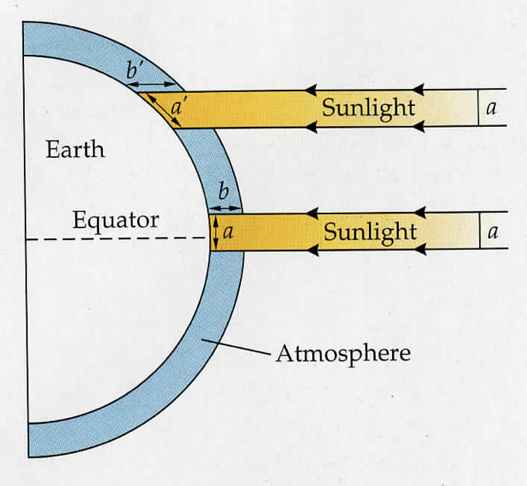
1) a vs a’ [2 points]

2) b vs b’ [2 points]
Figure 2. Average input of solar radiation to the Earth’s surface as a function of latitude.

Question 3 [4 points for parts a and b]: a) On the map (Figure 3), draw horizontal bars to show the location and the N/S degrees of the Horse latitudes [1 point]. b) Use Figure 3 of ocean circulation patterns to explain where we see the Earth’s deserts [3 points].
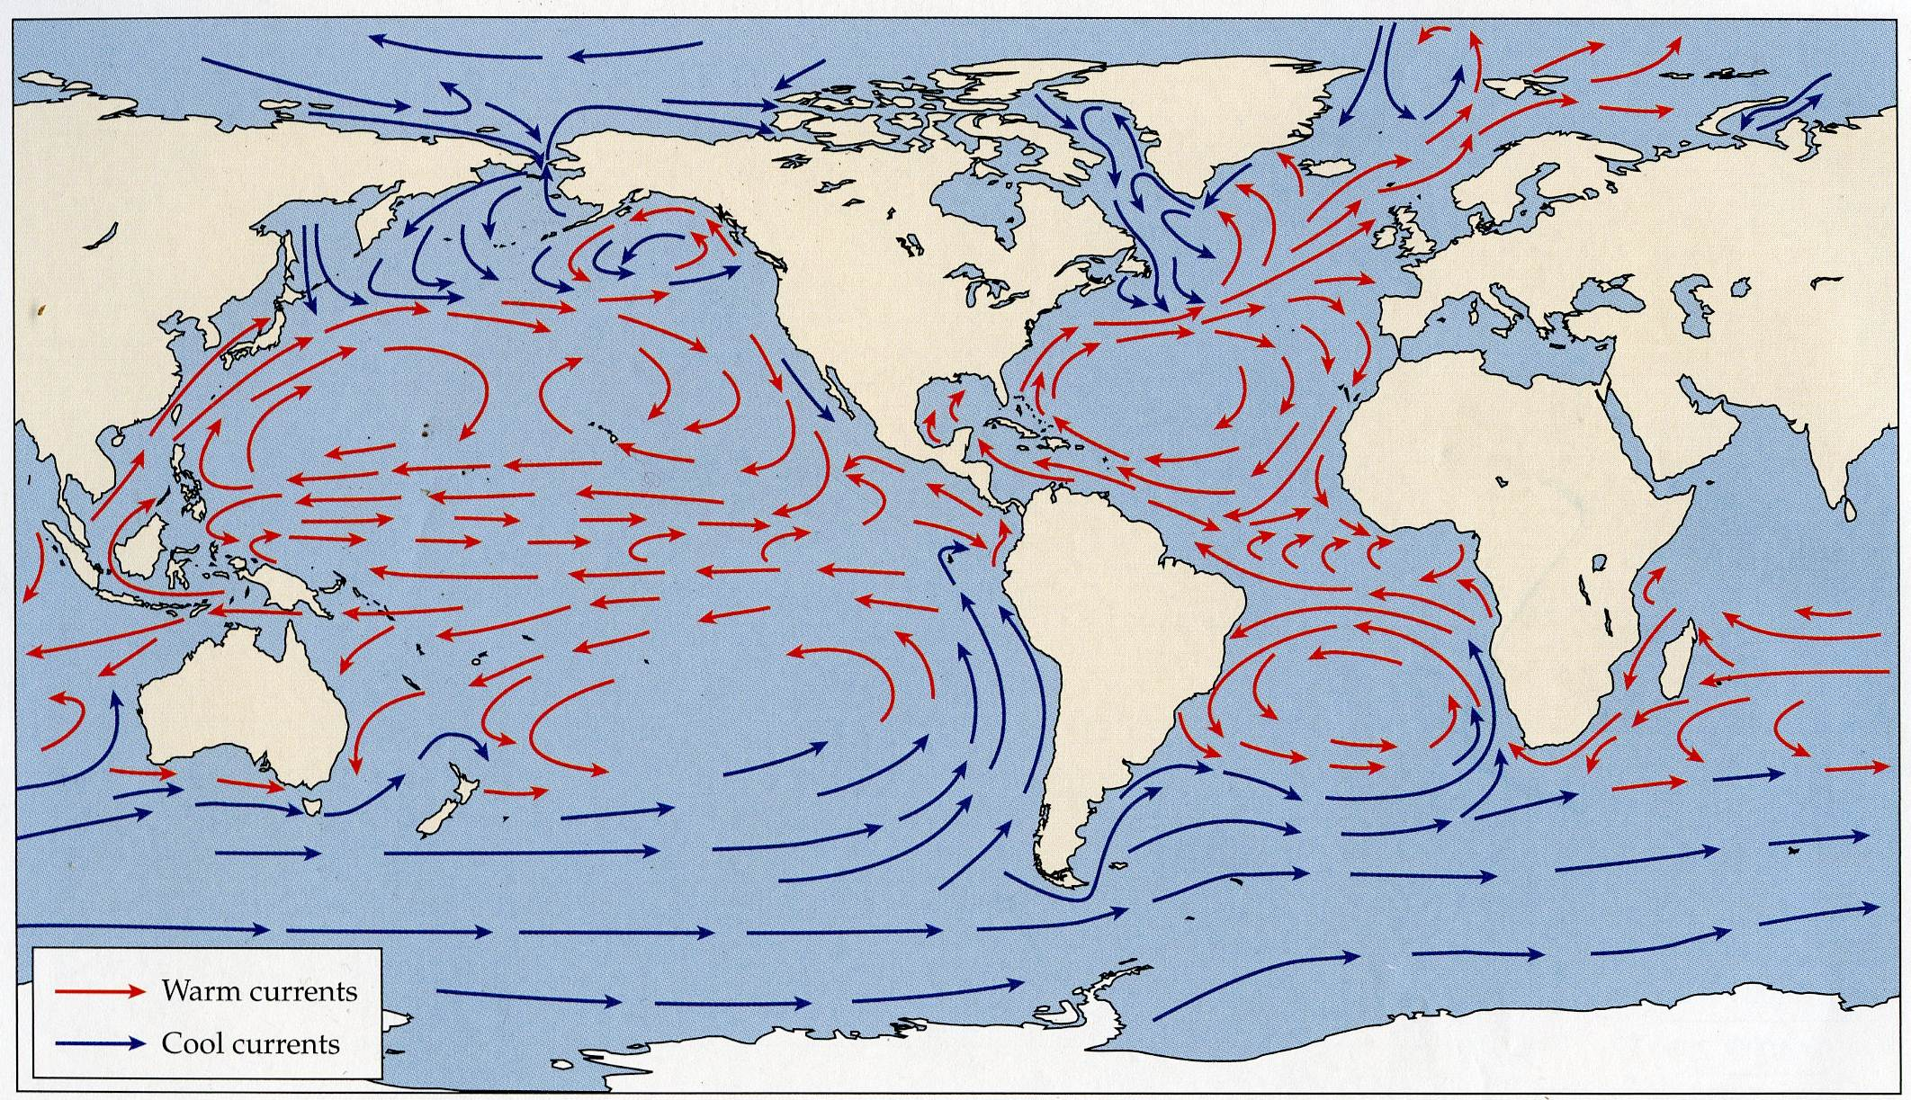
Figure 3. Main circulation patterns of surface ocean currents. Warm currents are in red, cold currents in blue.

Question 4 [3 points]: The European Starling is a widely distributed invasive species found across North America. Human-mediated dispersal resulted in its establishment outside of Eurasia in Central Park, New York. Describe how the starling’s distribution, and that of many exotic invasive species, is a result of both jump and diffusive dispersal.
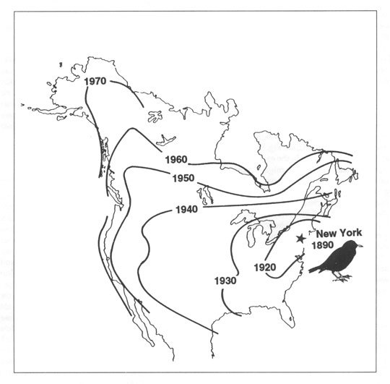
Question 7 [4 points]: Haffer’s (1969) hypothesis represents the “old view” that “islands” of Amazonian lowland rain forest persisted during the last glacial maxima and can be used to explain current patterns of disjunct taxa and speciation. The “new view” is that the Amazon did not exhibit isolated forest refugia during the Pleistocene. Provide two specific lines of evidence that supports the new view.
(Hint: one is from botanical data and one comes from animal taxa).

Question 6 [4 points]: We covered three dominant cycles that together make up the Milankovitch cycles and three related feedback mechanisms that were associated with the growth/retreat of ice sheets, which contributed to rates of cooling and warming. List two of the three cycles (2 points) and two of the three feedback mechanisms (2 points).

PART II
Answer the following Questions 7-9, using complete sentences.

Question 7 [8 points]: In class, we reviewed four different modes of geographic speciation (allopatric, peripatric, parapatric and sympatric). What evidence or information is required to show that two species diverged in allopatry versus peripatry? [4 points] What criteria must be met to conclude that a speciation event occurred under the sympatric model (provide two criteria)? [2 points] Why is sympatric speciation so difficult to demonstrate? [2 points]
Question 8 [8 points]: In class we reviewed the example of Siberian populations of greenish warbler, which demonstrate “speciation in a ring” around the Tibetan Plateau. The map (centre) shows colours indicating ranges and sonograms for six recognized subspecies of Phylloscopis trochiloides (left). The red and blue subspecies are reproductively isolated. The PCA (right) shows differences in songs characteristics among subspecies groups. Which mode of geographic speciation best describes this system? Explain your reasoning.
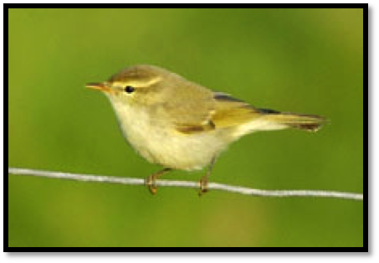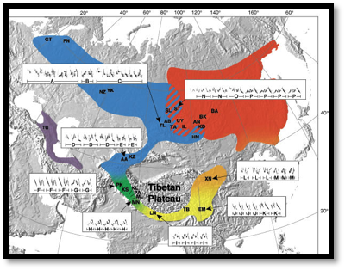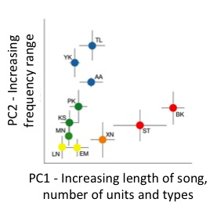
Question 9 [12 points]:
In class, we discussed numerous potential determinants of species distributions in the context of the fundamental and realized niche. In the space provided, define the fundamental and realized niche
[4 points] and provide four possible determinants of species distributions as they relate to the fundamental/realized niche concept, using an example (actual or hypothetical) to support your answers [8 points].

