Biology 413 (Zoogeography) Practice Mid-term Exam
Winter Term 2 – 2020 - KEY
Directions:
- Write your name and student number on each page of the exam.
- Use the space provided for your answers. You can use the back of the final page for extra space, but label your answers clearly. If you need additional sheets of paper, let me know.
- You will have 50 minutes to complete the exam. Plan accordingly.
- The exam questions are organized into two parts and consist of 5 pages.
- PART I consists of 6 short-answer and multiple part questions.
- PART II consists of 3 long-answer (essay-form) questions.
Marks
PART I: 22 points
PART II: 28 points
TOTAL: 50 points

PART I
Answer the following questions 1 – 6, using 1-2 sentences or less (point-form is OK) in the space provided. These questions should take no more than 3-5 minutes each.

Question 1 [3 points]:
El Niño Southern Oscillation (ENSO) is an irregular period of weather change that occurs every 2-7 years due to strengthening of the equatorial countercurrent over the tropical eastern Pacific Ocean.
How does ENSO positively or negatively affect land and marine animal communities in these regions?

The strengthening of the equatorial counter current over the tropical eastern Pacific Ocean brings warm surface currents to these regions. This results in heavy precipitation on land (currents/offshore winds are warmer than land). Higher precipitation benefits land animal communities (more precipitation generates more plant growth/higher resources), but the warm currents results in less upwelling and lower nutrients/resources for marine animal communities.

(The stronger warm equatorial countercurrent weakens the coastal Humboldt current along the South American coastline, which generates lots of upwelling and nutrients)

Question 2 [4 points]: Comparing a to a’ and b to b’ (Figure 2), explain the differential heating of Earth’s surface at low versus high latitudes:
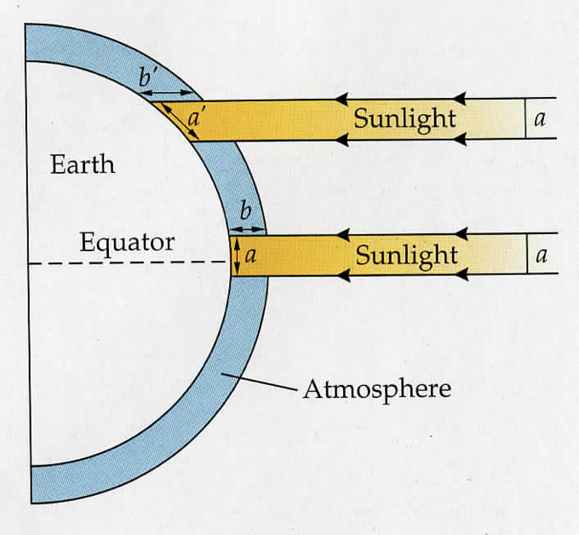
1) a vs a’ [2 points]
a has a smaller surface area compared to a’, so Earth’s surface at a receives more direct energy/solar radiation compared to a’
2) b vs b’ [2 points]
Figure 2. Average input of solar radiation to the Earth’s surface as a function of latitude.
in b, sunlight travels a shorter distance through less atmosphere compared to b’, so b’ filters more direct energy/solar radiation compared to b

Question 3 [4 points for parts a and b]: a) On the map (Figure 3), draw horizontal bars to show the location and the N/S degrees of the Horse latitudes [1 point]. b) Use Figure 3 of ocean circulation patterns to explain where we see the Earth’s deserts [3 points].
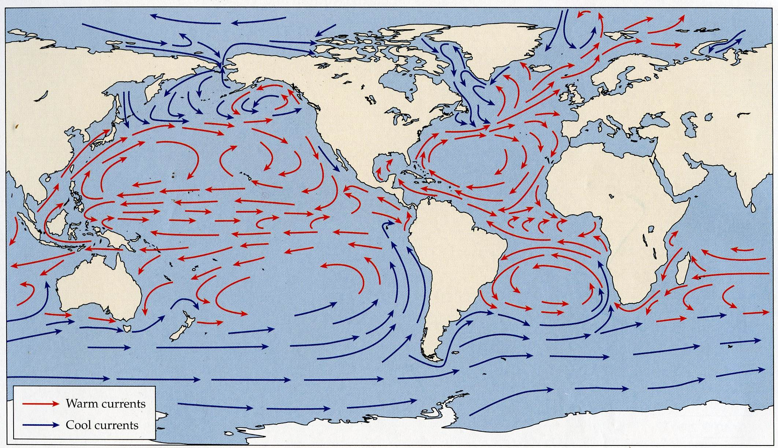
Over land, Horse Latitude belts (30° N and S latitude) represent the world’s deserts and Mediterranean climates. In summer, land is warmer than ocean water, and cool westerly winds over oceans absorb water as the air warms and expands while passing over warmer land. In winter, land is cooler than the ocean and moisture-laden westerly winds can bring precipitation to these regions, but this is minimal. The world’s driest deserts occur where very cold currents/winds encounter warm land, on the western side of continents at the Horse latitudes (e.g., Atacama desert in South America, western Australia, Namib Desert in Africa).
Figure 3. Main circulation patterns of surface ocean currents. Warm currents are in red, cold currents in blue.
Question 4 [3 points]: The European Starling is a widely distributed invasive species found across North America. Human-mediated dispersal resulted in its establishment outside of Eurasia in Central Park, New York. Describe how the starling’s distribution, and that of many exotic invasives, is a result of both jump and diffusive dispersal.
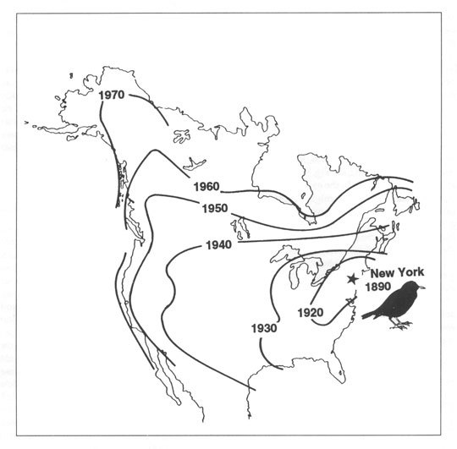
With jump dispersal, new habitats or areas are colonized with a single long-distance dispersal event. Diffusive dispersal is the gradual expansion of a species range through repeated short-distance colonization or dispersal events. Human-mediated introductions to continents is an example of jump dispersal over impassible water bodies. The European Starling was introduced to New York by humans (jump dispersal). Following the initial colonization, the starling’s range expanded across North America gradually via diffusive dispersal.

Question 5 [4 points]: Haffer’s (1969) hypothesis represents the “old view” that “islands” of Amazonian lowland rain forest persisted during the last glacial maxima and can be used to explain current patterns of disjunct taxa and speciation. The “new view” is that the Amazon did not exhibit isolated forest refugia during the Pleistocene. Provide two specific lines of evidence that supports the new view.
(Hint: one is from botanical data and one comes from animal taxa).
From botanical data: fossil pollen data from lake cores shows continuous forest cover and invasion by cold-adapted species during the last glacial maximum. From animal taxa: range limits of trumpeter species in South America indicate separation by large river systems, not glacial refugia. The timing of diversification events shows that speciation of trumpeters occurred before the last glacial maxima.

Question 6 [4 points]: We covered three dominant cycles that together make up the Milankovitch cycles and three related feedback mechanisms that were associated with the growth/retreat of ice sheets, which contributed to rates of cooling and warming. List two of the three cycles (2 points) and two of the three feedback mechanisms (2 points).
With the growth and retreat of ice sheets, respectively, there was a 1) decrease and increase in plant and animal life over large areas, 2) decline and increase in production of greenhouse gases and 3) and increase and decrease in the amount of white surface on the earth, owing to an increase and decrease of the albedo effect.

PART II
Answer the following Questions 7-9, using complete sentences.

Question 7 [8 points]: In class, we reviewed four different modes of geographic speciation (allopatric, peripatric, parapatric and sympatric). What evidence or information is required to show that two species diverged in allopatry versus peripatry? [4 points] What criteria must be met to conclude that a speciation event occurred under the sympatric model (provide two criteria)? [2 points] Why is sympatric speciation so difficult to demonstrate? [2 points]

Allopatric and peripatric speciation are the result of populations diverging from isolation by a geographic barrier. To differentiate between these two modes of speciation, we need to know when the geographic barrier was established with respect to when the populations became isolated. In allopatric speciation, we need evidence that a single large population existed prior to the generation of a geographic barrier. After the barrier was established, the isolated populations diverged in the absence of gene flow to eventually become separate species. In peripatric speciation, we need evidence to show that individuals from a population actively colonize unoccupied habitat across a geographic barrier

Sympatric speciation is the mode of speciation that occurs within spatially overlapping populations. In this case, two populations overlap extensively when population differentiation begins and populations maintain contact throughout the speciation process until two new species are recognized. As such, sympatric speciation requires divergent selection in the face of ongoing gene flow. We discussed four criteria that must be met to recognize a case of sympatric speciation: (1) Populations must be sympatric or overlapping in distribution; (2) The species that form must have substantial (genetically-based) reproductive isolation; (3) Sympatric species must be sister species, or must be the most closely related taxonomic groups in a given clade; (4) the biogeographic history of the species that are formed should make any allopatric phase in the speciation process highly unlikely (i.e., there is no evidence to suggest that populations were at one time isolated to allow divergence in allopatry).

It is difficult to gather sufficient historical biogeographic evidence to show that two populations were never isolated, or never had an allopatric phase. There must be sufficient evidence to show that populations were continually exchanging genes in the entire process of divergence (satisfying the last criterion is particularly difficult).

Question 8 [8 points]: In class we reviewed the example of Siberian populations of greenish warbler, which demonstrate “speciation in a ring” around the Tibetan Plateau. The map (centre) shows colours indicating ranges and sonograms for six recognized subspecies of Phylloscopis trochiloides (left). The red and blue subspecies are reproductively isolated. The PCA (right) shows differences in songs characteristics among subspecies groups. Which mode of geographic speciation best describes this system? Explain your reasoning.
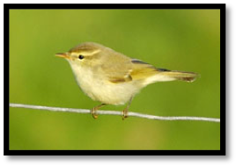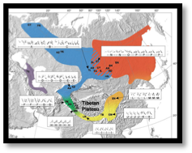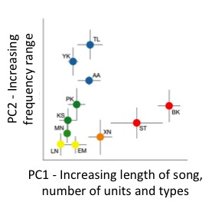
In this example of speciation in a ring, we see populations of greenish warblers with similar song characteristics, which are connected at the southern base of the Tibetan Plateau. Over time, these populations have spread north and separately along the eastern and western edges of the plateau and eventually come back into secondary contact along the northern border of the plateau (red and blue populations). With isolation in space and over time, these populations experience gradual divergence in song characteristics through their northward expansion. Songs are highly divergent and complex upon secondary contact and likely serve as a premating reproductive barrier.
We can infer that populations spreading northwards on either side of the plateau never experience genetic exchange (e.g., green and orange populations), and therefore are allopatric. The mode of speciation is best described as divergence in allopatry, with sufficient divergence in song characteristics used for mate choice leading to the formation of new species upon secondary contact.
Question 9 [12 points]:
In class, we discussed numerous potential determinants of species distributions in the context of the fundamental and realized niche. In the space provided, define the fundamental and realized niche
[4 points] and provide four possible determinants of species distributions as they relate to the fundamental/realized niche concept, using an example (actual or hypothetical) to support your answers [8 points].
The fundamental niche is the total range of abiotic environmental conditions in which a taxon can survive and reproduce. From Hutchinson, the n-dimensional hypervolume (or multidimensional space) that describes the range of abiotic environmental conditions in which a taxon can survive and reproduce (each abiotic factor is a single dimension). The realized niche is a subset of the fundamental niche comprising the actual environmental conditions in which a taxon survives and reproduces in nature, including biotic factors (e.g., competition, predation, mutualism, parasitism). (4 points)
There are many possible determinants of distributions, including abiotic interactions (e.g., climate/soil related factors), biotic interactions (i.e., direct/diffuse competition, predation, parasitism, mutualism), metapopulation dynamics, disturbance and historical factors/dispersal barriers. Full credit given for describing four different factors supported by a logical example (2 points per example for 8 points total).

