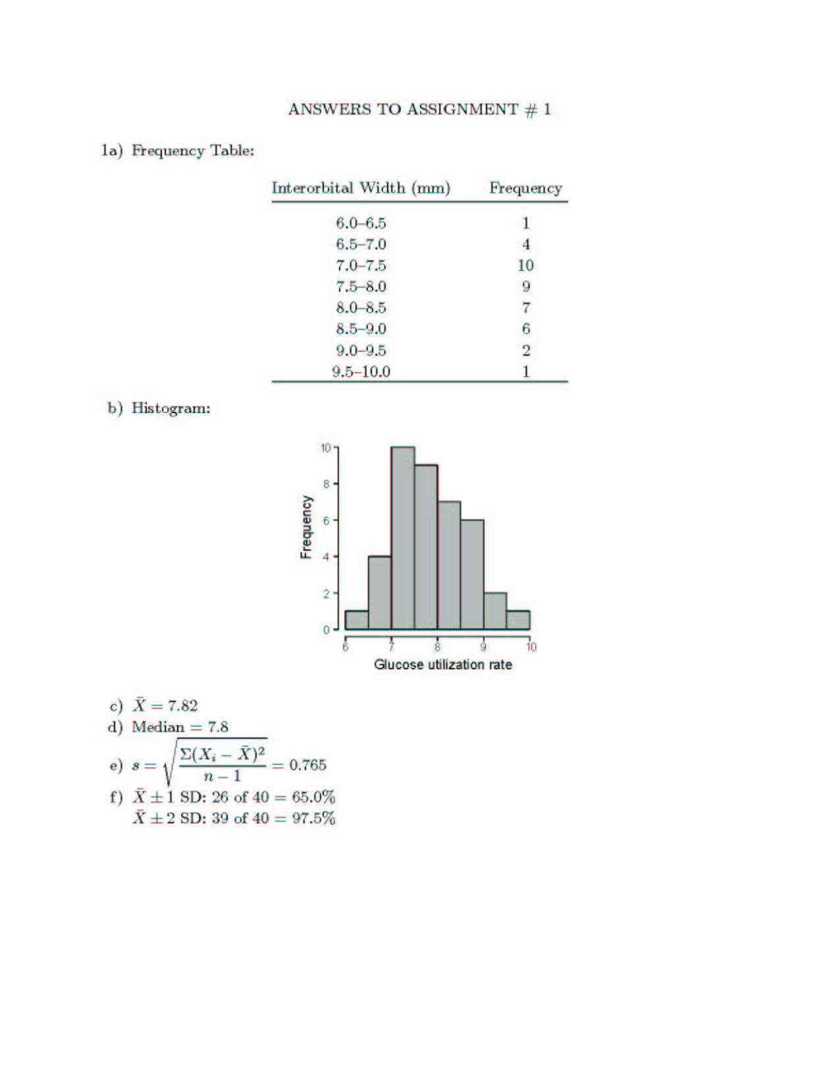

Glucose utilization rate

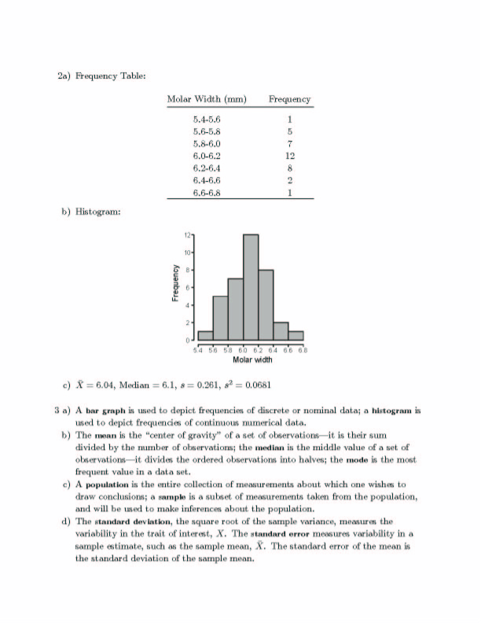

e) A random sample is one in which each member has an equal and independent chance of being selected. A non-random sample is one which does not meet these criteria
and so may have a bias.
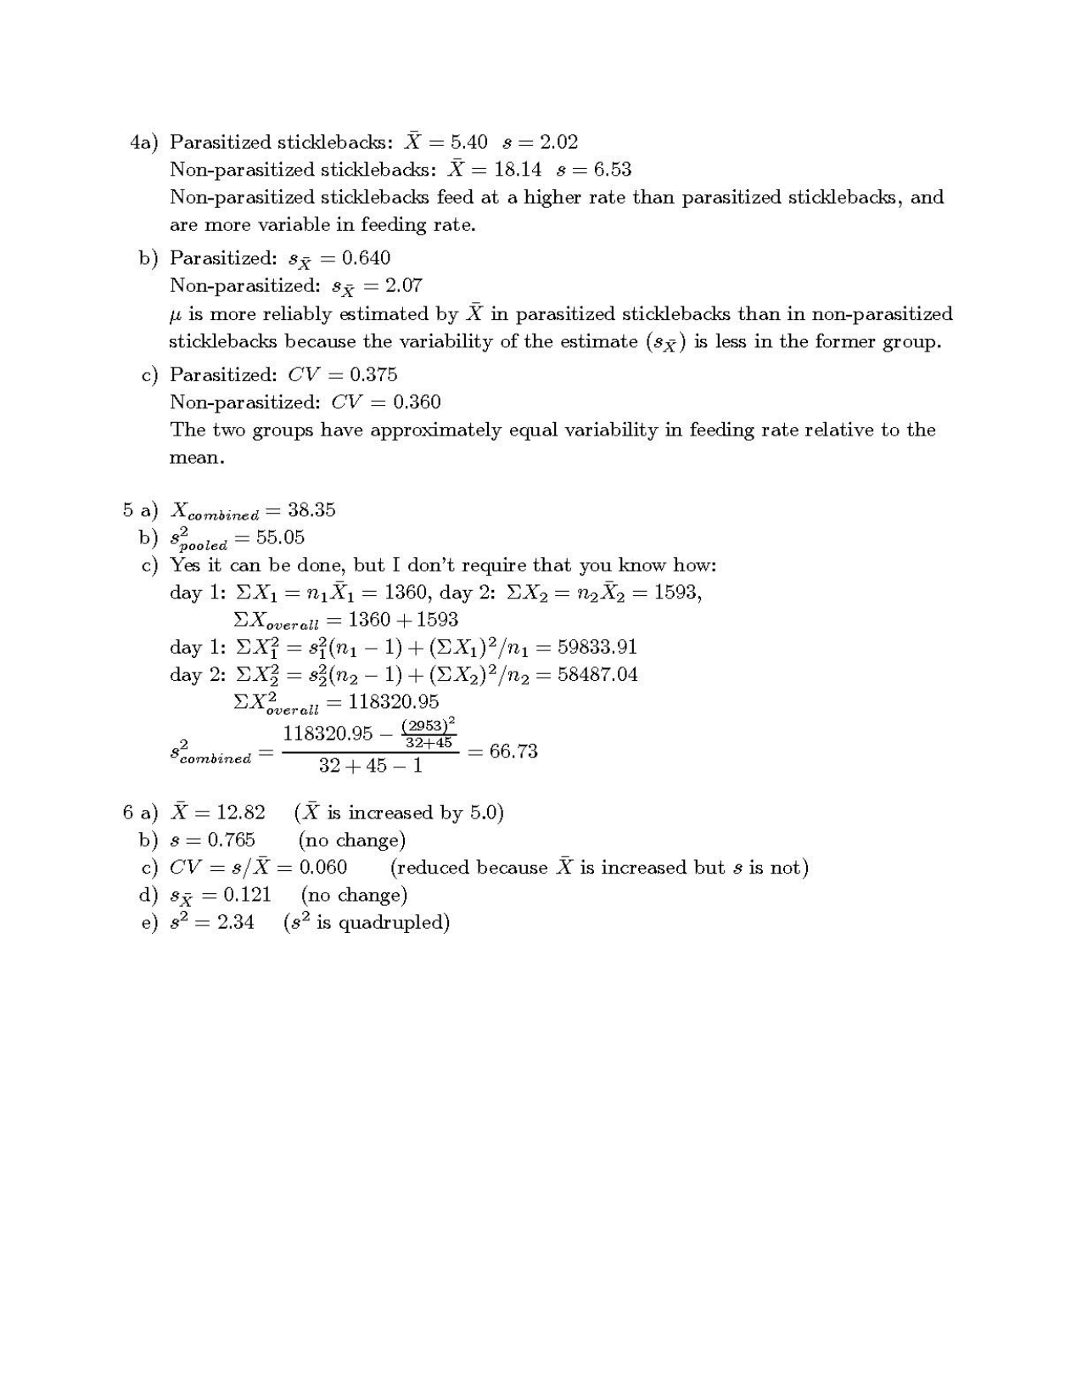
f) A parameter is a quantity that describes or characterizes a population, e.g. a measure of central tendency such as the mean. A statistic is an estimate of a population parameter (also known as a sample statistic).
5.16 s = 1.92
18.27 s = 6.93
0.61
2.19
0.372
0.379

